DOWN THE TRACK….
You are now familiar with the Compostworm and may want to review/improve your compost operation. The following tips may provide some assistance:
- If your bin is usually filling in about 5-6 weeks, use a second bin in tandem with the first. Fill one bin first, establishing good aeration and moisture content using the COMPOSTWORM (say weekly). Start filling the second bin, Continue aeration and turning of the first bin weekly and remove the completed compost from the first bin after about 6 weeks (depends on weather).
Alternate the role of the first and second compost bins.
Two “smaller” bins are preferred to one large bin. The tandem system is easier to manage and keep track of than a single bin operation also harvesting occurs more regularly.
- If a single compost bin is adequate for your needs and you have a problem stockpiling while the contents break down, consider using a continuous operation. Try and keep your bin, on average, about two-thirds full. The larger mass provides more stable conditions for natural composting processes to occur. Mix in and aerate new materials in the top section of the bin, Aerate the older material in the bottom section without mixing (i.e. fluffing).
Remember-Every 5 weeks or so, remove bottom layer of “finished” compost. Start at one side of the bottom of the compost bin with the Compostworm. And establish a “pattern” of removal, working towards the other side. With a little practice, you should find the continuous system workable.
Two bins in tandem, however is simpler and more effective with much better control- eg. correcting problems, unwanted mixing of old and new
- If you cannot avoid coarse prunings in bin, or if you wish to operate with a layered structure, you can use the fluffing technique to aerate during tools decent then, reverse rotation of the screw (instead of lifting tool), leaving material behind. Remember, turn over may still be required and will be harder and composting much slower with the coarser material.
SUGGESTED GRIP ------ (always wear leather garden gloves)
- Position left hand on shaft (near top)
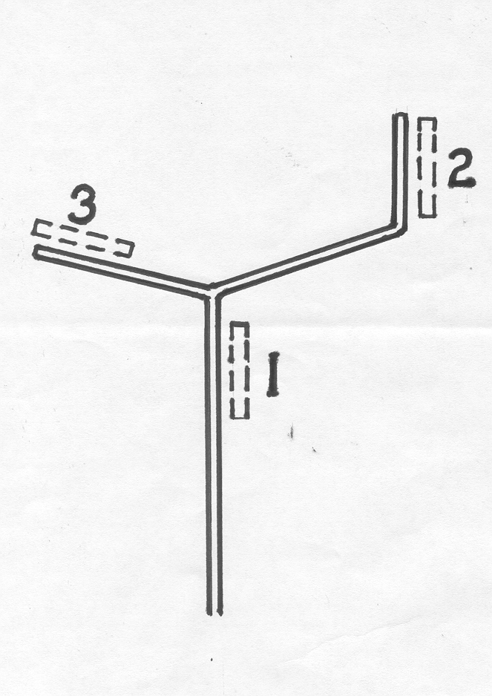
- Right hand using a cranking grip-rotate tool clockwise and it will screw into the contents.
- As tool approaches bottom or handle nears rim, reposition left hand to a tee grip operation to complete decent then lift with both hands.
Happy Composting
04/06
COMPOSting tool*–

the

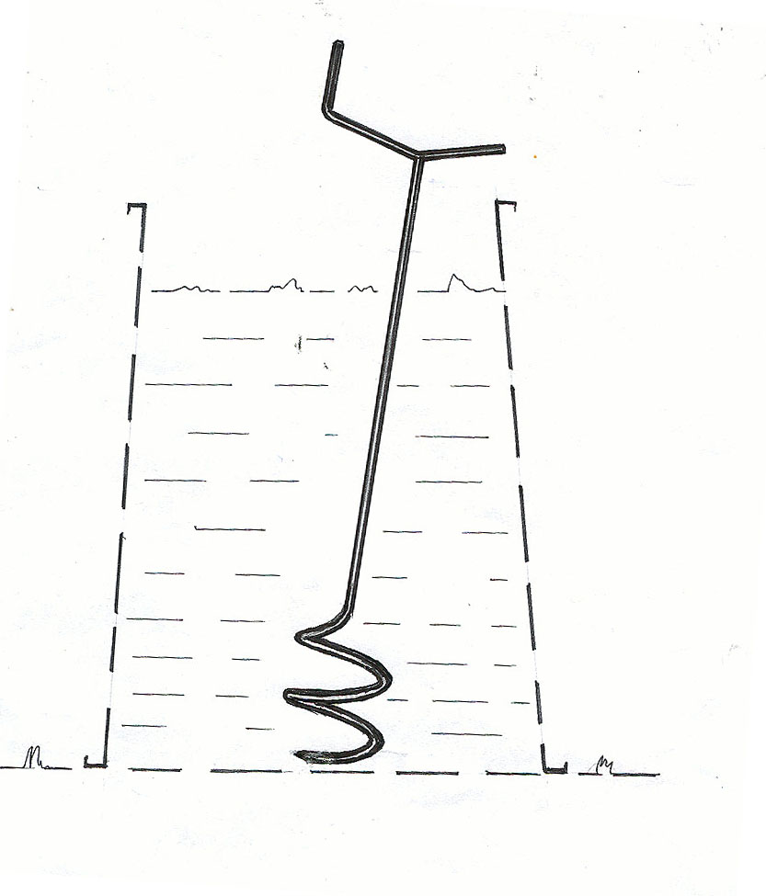
*
Developed by Dion Kentwell
83 Gordon Ave., Hamilton 2303
Ph: (02) 4969 1468
Email-- compostworm@bigpond.com
*Registered Des. 140664
Patent No. 764238

THE COMPOSTWORM
(for on ground plastic bins)

The COMPOSTWORM works to the full depth of the bin and provides a clean and effective method of turning, aerating and managing your compost bin.-The Tool is lightweight

All operations are carried out in the bin, No need to lift bin, fork over and then replace entire contents---You can stop turning compost in the bin with the COMPOSTWORM as soon as you think “that’s enough”
*********************
Enclosed bins provide a tidy operation (neighbours, children and animals) and protect your operation from the elements (heat and moisture loss) and vermin. Contact with the ground assists the composting process to operate at it’s best and encourages worm activity as the process cools down.
Using the Compost worm--.:-(refer to sketch for suggested grip)
- Rotate the Tool clockwise to screw into your compost bin contents to the required depth (don’t try to push tool into mix). Without rotation lift the Tool raising captured material to the surface.. Repeat in several positions to complete a rough traverse of the bin and the Tool will progressively turn over and aerate your bin’s contents.
If the tool catches or lift is heavy reverse and unscrew a turn or so to reduce the load
- Fluffing- Loosen the material during decent; i.e. after each four or five turns lift the tool several cm’s (use a pumping action,) to fluff the material,
Do this especially with a heavy or neglected mix..
Note--Use a pumping action when lifting tool to increase fluffing.
- You can use the tool to take compost from the bin’s bottom for your garden or potting mix. Give the Tool a quick twist to clear into a bucket.
- Use the COMPOSTWORM to monitor and establish the conditions in the bin. Two or three minutes of work each week will put you in control.
- Successful Operation of Compost Bins:
- Composting is a process to speed up nature’s little wonder workers to reduce dead organic material to HUMUS by optimising the conditions in the bin. Most problems associated with home composting are attributed to poor aeration and moisture control. These together with a diverse range of material are necessary for the natural composting processes to flourish in the compost bin.
- The contents of the bin must be aerated for aerobic breakdown (the natural process that forms healthy compost). Aerate your bin once a week and prior to large additions.
- Keep the contents moist, this is important
- Materials you can place in your compost bin include kitchen food scraps, garden wastes--leaves, lawn clippings, prunings, manure, vacuum cleaner dust, shredded paper, tea bags, coffee grinds etc.—
if it was once alive, consider composting it! . Experiment a bit. Meat and dairy should be avoided, if you use citrus scraps you may need to add a little lime to sweeten (neutralise) your compost. Dynamic lifter, blood and bone, manures (especially fresh) etc. can be processed through the bin. The nutrients are retained in the compost and there is no associated smell when used on the garden.
- Add new materials as they become available. Diversity of materials is the key. Don’t layer material, use the tool to make it a “tossed salad”.
- After adding food waste use the tool to lift some older material. A quick twist of the tool will scatter the material to activate and cover scraps.
- Cut up your garden wastes with a mulcher, or, with care, the lawn-mower. Finer and damaged material breaks down faster and more uniformly in your compost bin, and you can fit more in the bin.
This pre-work is well worth the effort. Large pieces in the bin wont break down readily, Increasing composting time and generally hindering the operation
- The time it takes from the last addition of material to conversion into usable compost varies with bin location, season, temperature etc. With good compost practice it should take about 5-6 weeks then harvest!
- Enclosed bins are best located in a sunny and well- drained position,
- Use of the Tool allows the bin to stay in the same position so clear, level and loosen the soil in this area. A lower working height may suit some people so dig the“working” side into the ground (say 5 cms.) to tilt bin.
Troubleshooting:
The Compostworm provides on-going samples of the compost operation, use this facility to monitor the process.
With regular use of the Compostworm, problems should be few and readily rectified.
Compost bin contents are wet and/or smelly ? | Add dry material (usually browns -- dry leaves, sawdust, paper pieces etc) and increase aeration, some lime may be necessary if acidic.
Composting process appears to have stopped? | Usually because it is too wet or too dry. Correct this condition and re-activate by mixing in fowl manure or dynamic lifter and some old compost.. Greens such as grass clippings can be added also but may extend the process. Cover the surface (use an old hessian bag, old carpet)
Compost bin contents are dry? | Add some water, mix and check -- squeeze a handful of material, there should be moisture but no drips. (NB: it is easier to add moisture than dry out wet material). Always keep a lid on your bin.
Compost bin filling too fast? | This is often seasonal -- in Spring/Summer we mow our lawns more, in Autumn there are more leaves. Excess grass clippings and/or leaves can be spread in 5cm layers on the garden as mulch. Or, you can store and add to your bin later. Consider using an extra bin or use a mulcher mower on large lawns.
*Don’t overdo sawdust (very high in carbon), and balance by adding some dynamic lifter at the same time.

Like more INFORMATION?
Your local Council can provide waste information and educational material, and Councils may have facilities to recycle excess and heavy waste.

